

**Program: ESE 4009_1**

**INSTRUCTOR:** Prof**.** Mike Aleshams

# **Group 6**

|  |  |  |
| --- | --- | --- |
| Student Name | Student ID | Signature* |
| Rohan Yadav | C0773871 | ROHAN |
| Shahrukh Padaniya | C0769542 | SHAHRUKH |
| Swapnil Sevak | C0777195 | SWAPNIL |
| Vandana Eaga | C0777215 | VANDANA |

*\*By signing above you attest that you have contributed to this submission and confirm that all work you have contributed to this submission is your own work. Any suspicion of copying or plagiarism in this work will result in an investigation of Academic Misconduct and may result in a “0” on the work, an “F” in the course, or possibly more severe penalties.*

**Project Proposal**

**Project Title:**

**IoT based Cradle system using SIDS monitor**

**Description of the latest similar system:**

There are no similar products that function like ours in the current market. Although there are some products that measure an infant's oxygen and heart rate of a baby, there are other products that just function as a surveillance system.

**Product name:** 1) Owlet smart sock baby monitor

**Product Description:**

The Smart Sock is the first baby monitor to track your baby’s oxygen level and heart rate—the best indication of baby’s health—while they sleep. If your baby’s readings leave preset “safe” zones, you'll receive a notification that lets you know your baby really needs you. Now you can feel more confidence, more freedom, and more peace of mind knowing that Owlet is here to help you keep your baby safe.

**Product Image:**

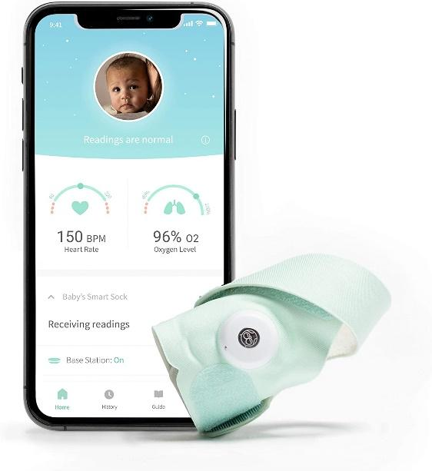

|  |  |
| --- | --- |
| Parcel Dimensions | 19.81 x 14.22 x 8.64 cm; 431 Grams |
| Batteries | 1 Lithium ion batteries required. (included) |
| Item model number | BM06NNBBYG |
| Safety warning | Warning Strangulation Hazard: Children have strangled in cords. Keep this cord and the base station out of the reach of children (more than 3 feet (0.9m) away from the crib). Do not remove this tag. The Owlet Smart Sock is meant for healthy babies up to 18 months of age and the notification thresholds on Owlet Smart Sock are not as stringent as a medical monitor. The Smart Sock is an information-gathering product intended to assist in tracking the well-being of healthy babies from 5 to 30 pounds. It is not a medical monitor or other medical device and is not intended to diagnose, cure, treat, alleviate or prevent any disease or health condition or investigate, replace or modify anatomy or any physiological process. You should always follow pediatrician-recommended safe sleep practices when using the Smart Sock |
| Target gender | Unisex |
| Compatible products | Tablets, Smartphones : smartphones|iphone 5|samsung galaxy s9 plus|samsung galaxy s4|iphone 7|android phones |
| Batteries required | Yes |
| Battery type | Lithium-Ion |
| Item Weight | 431 g |

**Limitations of the** 1) Owlet smart sock baby monitor

One of the major limitations of this product is that it can damage the skin of a baby as illustrated in the image below. Also this product lacks many features like surveillance system, playing melodious sounds when baby cries, automatic swing for cradle and notification to guardians through sms.

Second limitation of this product is false alerts. Sometimes the system gives false alerts to parents and it creates anxiety unnecessarily.

It was found by Rebecca Edwards (Security Expert, Safety & Tech Reporter) that it creates false alarms and increases tension among parents and sometimes it fails to register problems also which is the main drawback of this product.

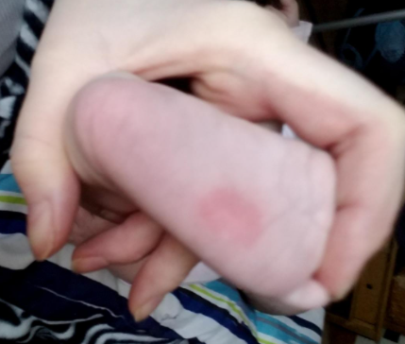

### **Product name:** 2)Nanit Pro Camera

**Product description:-**

Nanit pro camera is the baby monitor that keeps you in the loop with your baby’s overall development, including sleep, height, and breathing motion, while saving every precious milestone. It has temperature as well as humidity sensor, sleep tracking, HD video and two way audio system.

**Product image:-**

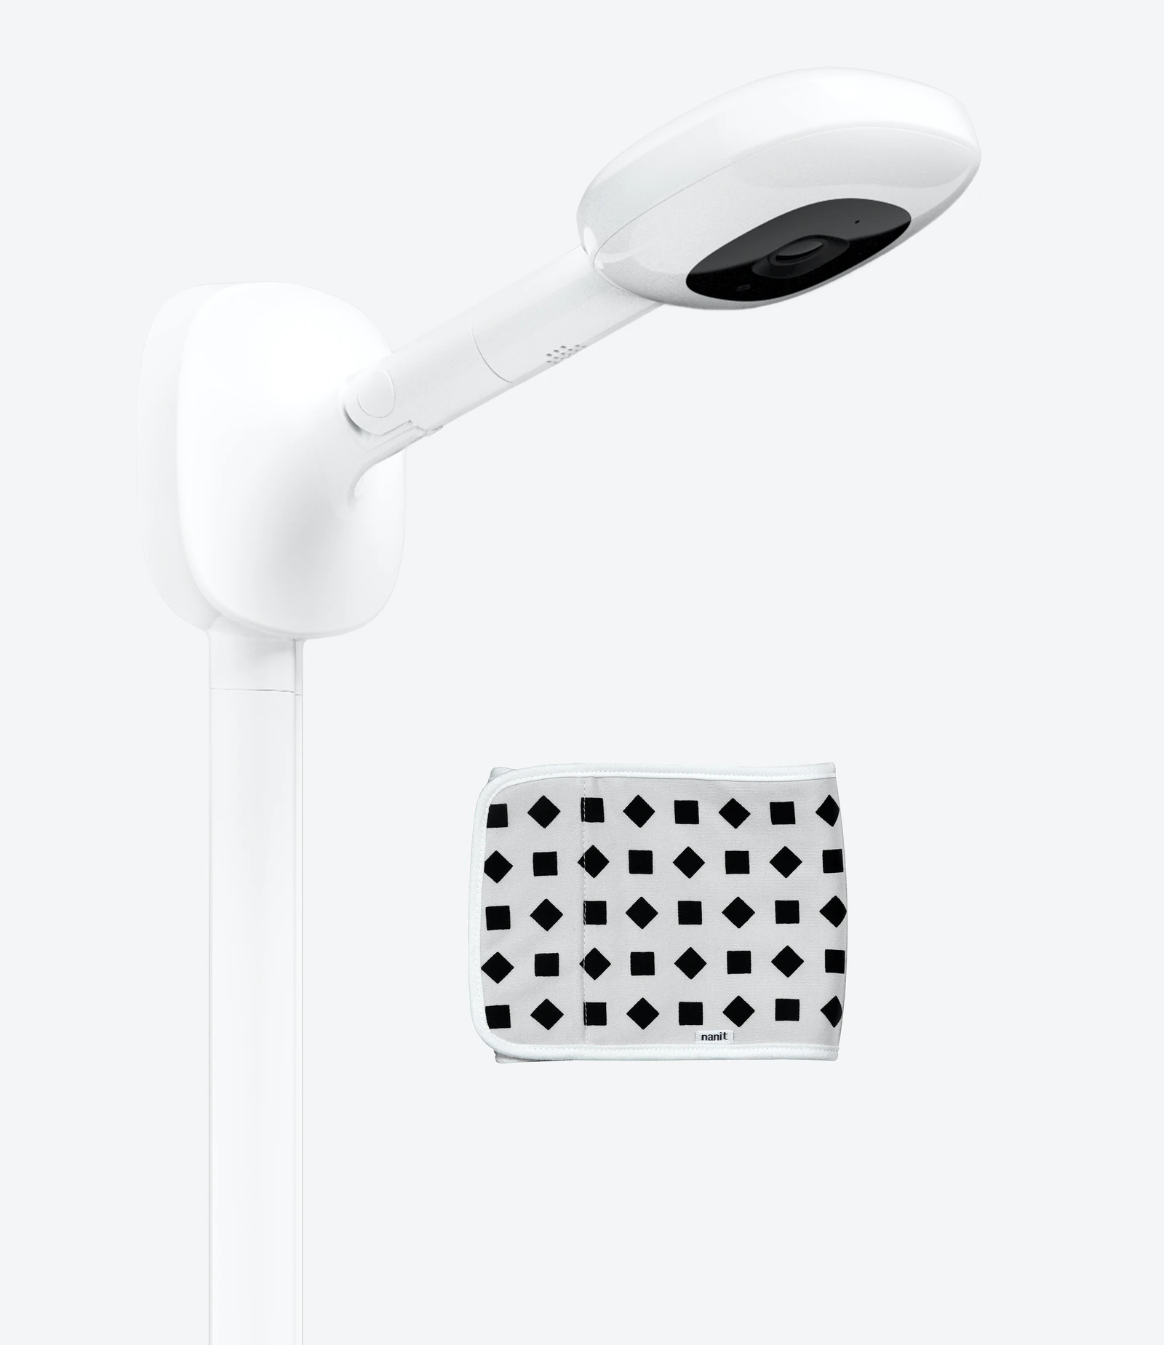

**Limitations of** 2)Nanit Pro Camera  
This product requires the baby to wear a belt around the body all the time to track heart rate. Also, it lacks other features like automatic swing control, melodious music and notification through sms whenever the internet is not available. Also the users have experienced trouble in connecting the system with the internet and sometimes the sleep tracking feature gives false readings.

**Initial Solution (in one or more pages)**

**(Block Diagram, Features, Hardware and Software Requirement, References):**

**Block Diagram:-**

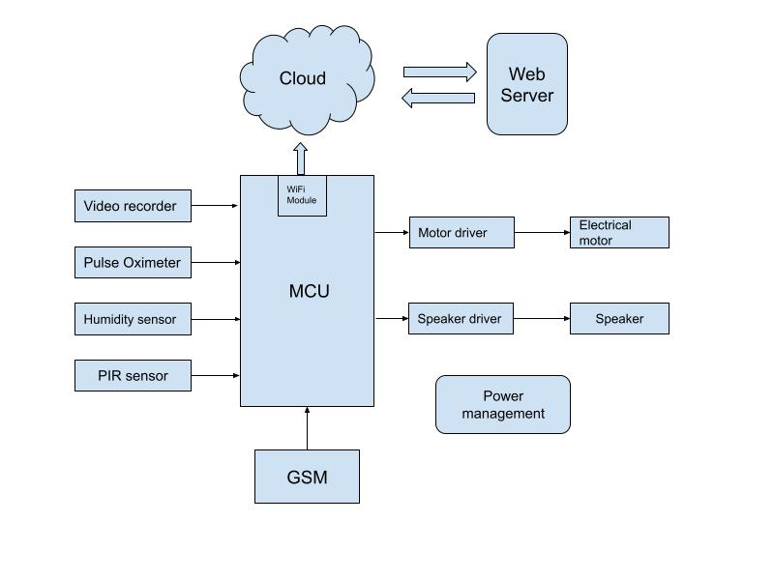

**Features of our project:-**

* SIDS monitor (sudden infant death syndrome)
* Cry detection
* Wetness detection
* Video Monitoring
* Swing control
* Provides alert in an emergency case
* Playing melodious music or sounds

**Hardware requirement:-**

* Microprocessor - RASPBERRY PI 3 MOD B+ BCM2837B0
* PIR sensor - HC-SR501
* USB camera and microphone - Logitech C920
* Speaker - USB mini speaker from Adafruit
* Humidity sensor - DHT11, DHT22 or AM2302.
* Electric motor - Servo Motor
* Motor Driver - L298N
* Pulse Oximeter - MAX30102
* GSM/GPRS Module - SIM868

**Software requirement:-**

* Raspberry Pi OS (Raspbian)
* C language, C++ or Python
* Kicad
* PCB Wizard
* Microsoft Azure

**Alternate solution:**

**Hardware component:**

**BeagleBone Black Rev - C:-** The BeagleBone Black is a low-cost credit-card-sized development platform with good support from a fast growing community. It comes with an onboard micro HDMI port, 512MB of DDR3L DRAM, 4GB onboard flash memory, an AM3358 (ARM® Cortex™-A8) processor at 1GHz, and making JTAG optional with a user-supplied header. Ultimately, the BeagleBone Black is still perfect for physical computing and smaller embedded applications.

Why do we choose beaglebone black?

The main reason that we choose BeagleBone Black is because it is capable of not just interfacing to all of the motor drivers, location or pressure sensors and 2D or 3D cameras, but also running OpenCV, OpenNI and other image collection and analysis software to recognize the objects around your robot and the gestures you might make to control it. Here we have used Beaglebone Black for processing.

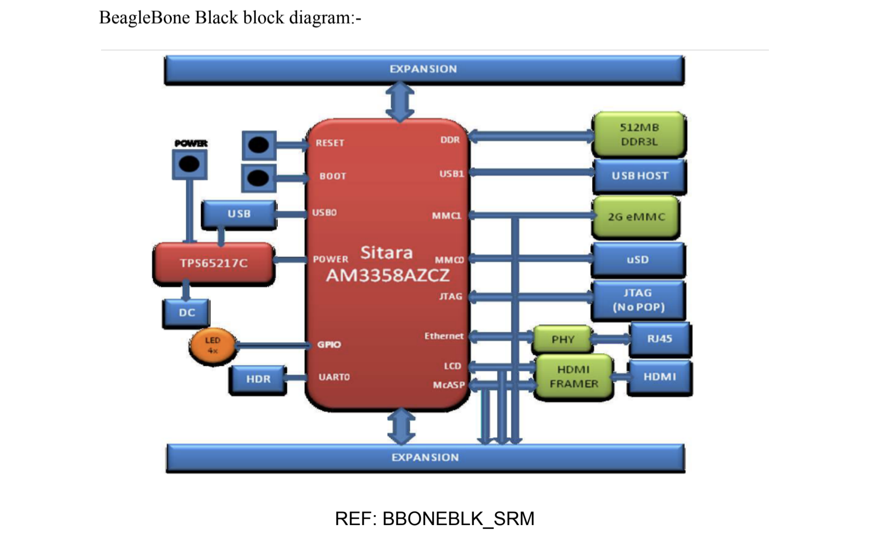

**Servo Motor vs DC Motor:**

**Difference Between Servo Motor and DC Motor in the tabulated form is given below.**

|  |  |  |
| --- | --- | --- |
| **BASIC** | **SERVO MOTOR** | **DC MOTOR** |
| Wire system | The Servo motor is a three wire system known as power, ground and control. | DC motor is two wire system known as power and ground |
| Assembly | It has an assembly of four things: DC motor, gearing set, control circuit and a position sensor. | A DC motor is an individual machine with no assembly. |
| Rotation | Servo motor does not rotate freely and continuously like a DC motor. Its rotation is limited to 180⁰ | Movement of DC motor is continuous |
| Examples | They are used in robotic arms, legs or rudder control. | DC motors are used in car wheels, fans etc. |

The Servo Motor is basically a DC motor which does not run continuously for a longer period of time. It has a unique arrangement which allows the motor to rotate at a specific angle with greater accuracy and precision. This machine is controlled by a feedback system.

Hence, a servo motor will be more appropriate to use for controlling the swing of a cradle.

**Software component:**

**Programming language:**

We have two options for programming, c and python. C is a general-purpose, procedural computer programming language.Python is an interpreted, high-level, general-purpose programming language.Compiled programs execute faster as compared to interpreted programs.Interpreted programs execute slower as compared to compiled programs.The syntax of a C program is harder than Python.Syntax of Python programs is easy to learn, write and read.

Main difference is that, we have to use c language to achieve real time features, we cannot achieve real time in python. Hence, we will use c in our project for achieving real time processes.

**Google cloud:**

* simpler and more understandable and low cost than other cloud services.
* It provides cloud SDK
* IT is a unified CLI for all services, and is cross-platform, with binaries available for Windows, Linux, and macOS.

**Thingspeak:**

* real-time data collection
* data processing
* Visualizations
* Some of it features are free

**Amazon AWS:**

Amazon Web Services (AWS) is the market leader in IaaS (Infrastructure-as-a-Service) and PaaS (Platform-as-a-Service) for cloud ecosystems, which can be combined to create a scalable cloud application without worrying about delays related to infrastructure provisioning (compute, storage, and network) and management.

With AWS you can select the specific solutions you need, and only pay for exactly what you use, resulting in lower capital expenditure and faster time to value without sacrificing application performance or user experience.

It provides below features for free for 1 months:

Amazon EC2 Service

Amazon S3 Service

Amazon RDS Service

Amazon Elastic Load Balancing

Amazon DynamoDB Service

Amazon ElastiCache Service

Amazon CloudWatch Service

Amazon SES Service

Amazon SNS Service

Amazon SQS Service

Amazon SWF Service

AWS Data Transfer In

AWS Data Transfer Out

AWS Support (Basic)

**Microsoft Azure:**

Microsoft Azure, popularly known as Windows Azure is a cloud computing platform built by Microsoft for building, managing and deploying the applications and services through the network of Microsoft data centers. It helps you move faster, do more and save money. Be it a small business or an enterprise, Windows Azure is capable of providing cloud computing services that can suit any need of internet solutions.

Here are some of the amazing features that Windows Azure offers:

**Iaas and PaaS**

Azure is the only cloud platform ranked as an industry leader by Gartner for both infrastructure-as-a-service and platform-as-a-service. It supports various programming languages, tools and frameworks and lets you build, deploy and manage applications any way you like.

**Hybrid Ready**

Some service providers make you choose between the public cloud and your data center. Azure offers you enterprise proven hybrid cloud solutions like amazon web services that can help you expand your IT options without added complexity. The data storage, backup and recovery become easier with Azure. Also, it becomes easy to build applications that span both cloud and on-premises.

**Open and Flexible**

Azure is open and flexible and supports any language, operating system, framework right from Windows to Linux, Oracle to SQL Server, C# to Java. It brings the best of Linux and Windows ecosystems and enables you to build robust Sharepoint applications and services that work well with every device.

**Scalable and Economical**

Azure is quite scalable and matches every demand so you can pay for what you use.

**Azure free service for 12 months:**

Linux Virtual Machines

Windows Virtual Machines

Managed Disks

Blob Storage 5GB

File Storage 5GB

SQL Database 250GB

VPN Gateway

Load Balancer

Azure Cosmos DB

Bandwidth (Data Transfer)

Notification Hubs

**PCB Design Software:**

We have two options for PCB design, First one is **KiCAD** and second is **Proteus**. Both are free and versatile. There are many tutorials available to learn from basic to advanced. These are steps to design PCB layout.

* Creating a Project
* Designing the schematic (Schematic using symbols and Wires)
* Lay out the board (Visibility options, Footprints, Traces and board outline)
* Improve the schematic (Power symbols, labels and electrical rule check)
* Improve the Layout (Updating from schematic changes, copper zones, vias, net selection and exchanging units)
* Get ready for manufacturing (Design rules and gerber export)

**ENGINEERING DRAWING:**

Design for our cradle

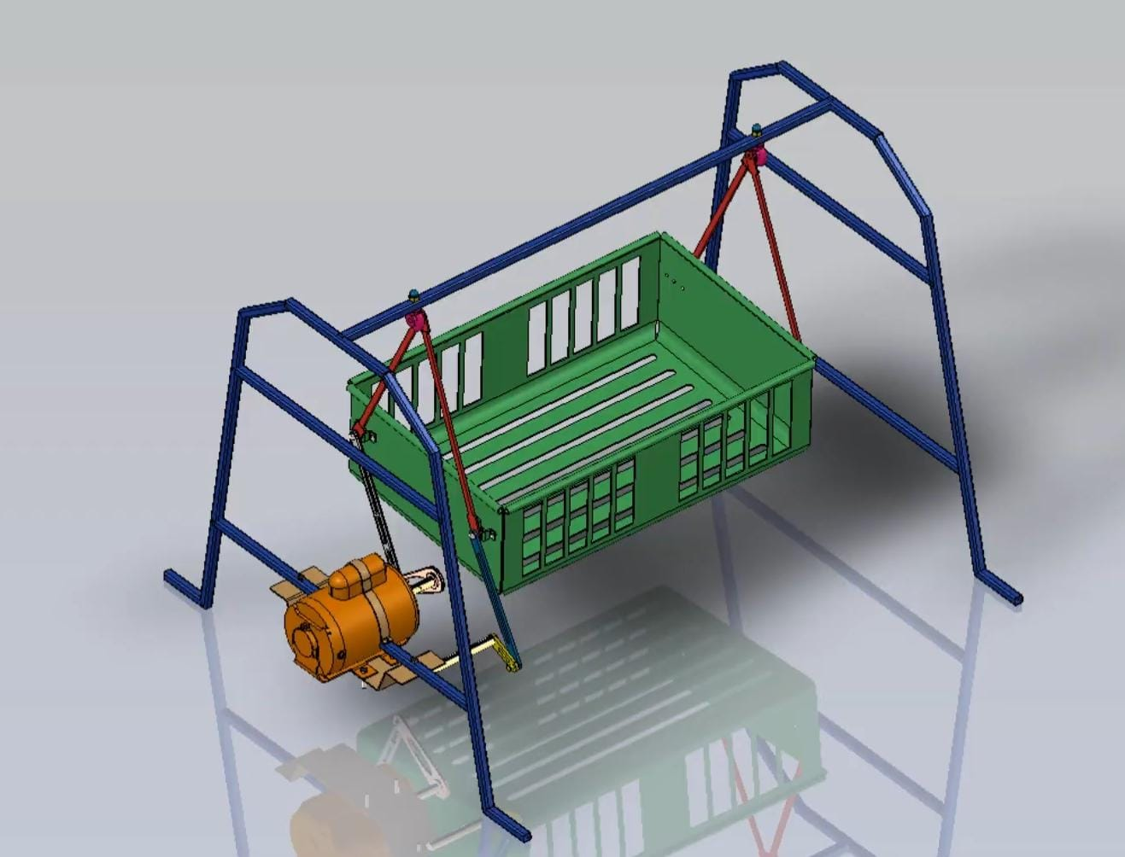

Design for our system

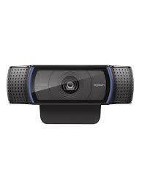

↓ ↓

 **←** 

↑

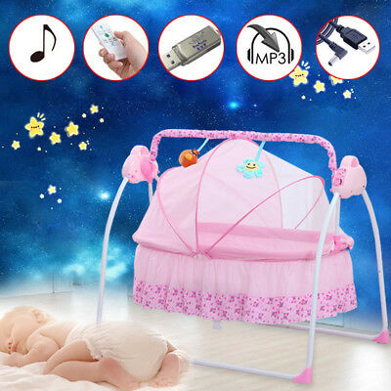

**Final Solution: (Don’t touch it for now, just after presentation)**

**(Block Diagram, Features, Hardware and Software Requirement, Milestones :Deliverables and Time Schedule):**

**Block Diagram:**



**Features of our project:-**

* SIDS monitor (sudden infant death syndrome)
* Cry detection
* Wetness detection
* Video Monitoring
* Swing control
* Provides alert in an emergency case
* Playing melodious music or sounds

**Hardware requirement:-**

* Microprocessor - RASPBERRY PI 3 MOD B+ BCM2837B0
* PIR sensor - HC-SR501
* USB camera and microphone - Logitech C920
* Speaker - USB mini speaker from Adafruit
* Humidity sensor - DHT22
* Electric motor - Servo Motor
* Motor Driver - L298N
* Pulse Oximeter - MAX30102
* GSM/GPRS Module - SIM868

**Software requirement:-**

* Raspberry Pi OS (Raspbian)
* C language, C++ or Python
* Kicad
* PCB Wizard
* Microsoft Azure

**Multitasking with Raspberry Pi -**

Multitasking and multiprocessing have become a very important topic in microcontroller-based systems, namely in complex commercial, domestic, and industrial automation applications. As the complexity of projects grows, more functionalities are demanded from the projects. Such projects require the use of multiple interrelated tasks running on the same system and sharing the available resources, such as the CPU, memory, and input-output ports. As a result of this, the importance of multitasking operations in microcontroller-based applications has grown steadily over the last few years. Many complex automation projects now make use of some form of a multitasking kernel.

The following multitasking is supported by Raspberry Pi :

* Fork
* Thread
* Subprocess
* Multiprocessing

Scheduling algorithm available in Raspberry pi :

* Co-operative scheduling
* Round-robin scheduling
* Preemptive scheduling

**FlowChart of whole system:**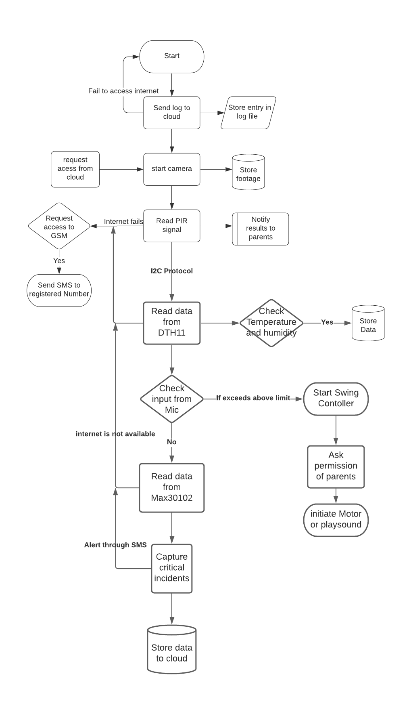

**1) Pulse oximeter monitoring**

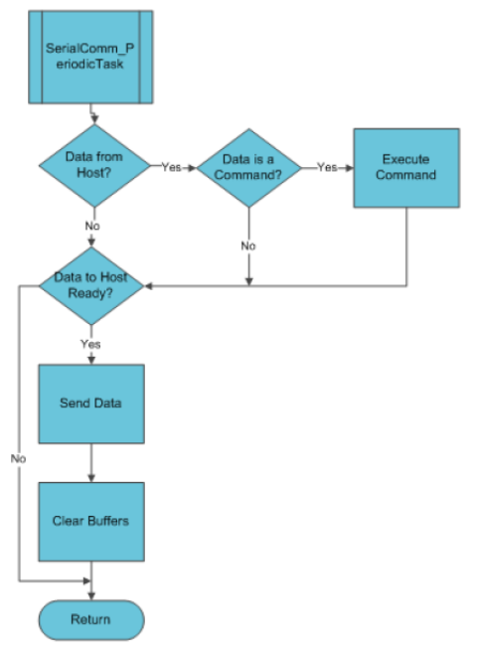

**2) Swing controller:**

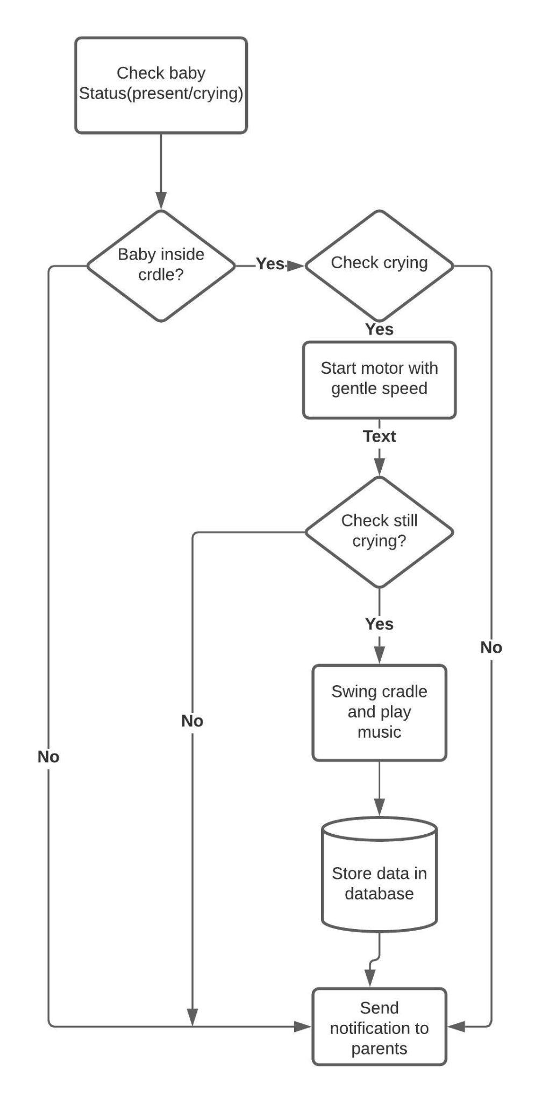

**3) Crying Detection:**

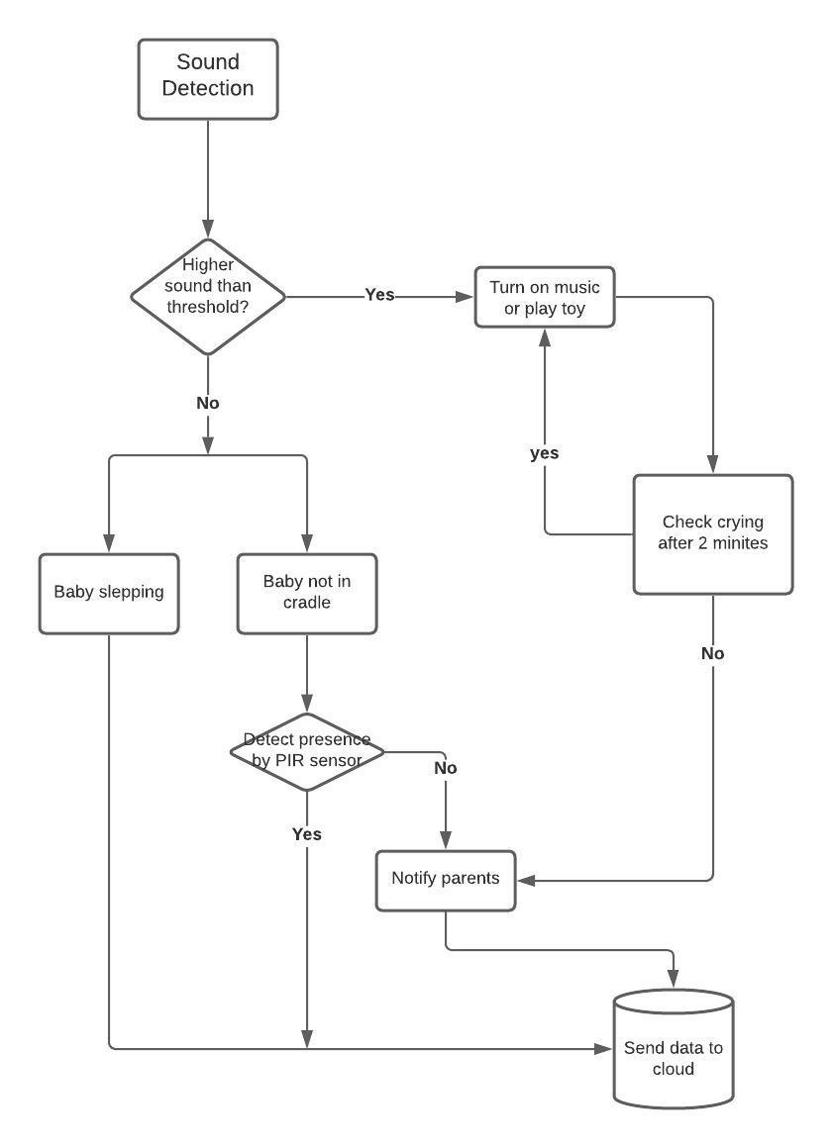

**4) Wetness Detection:**

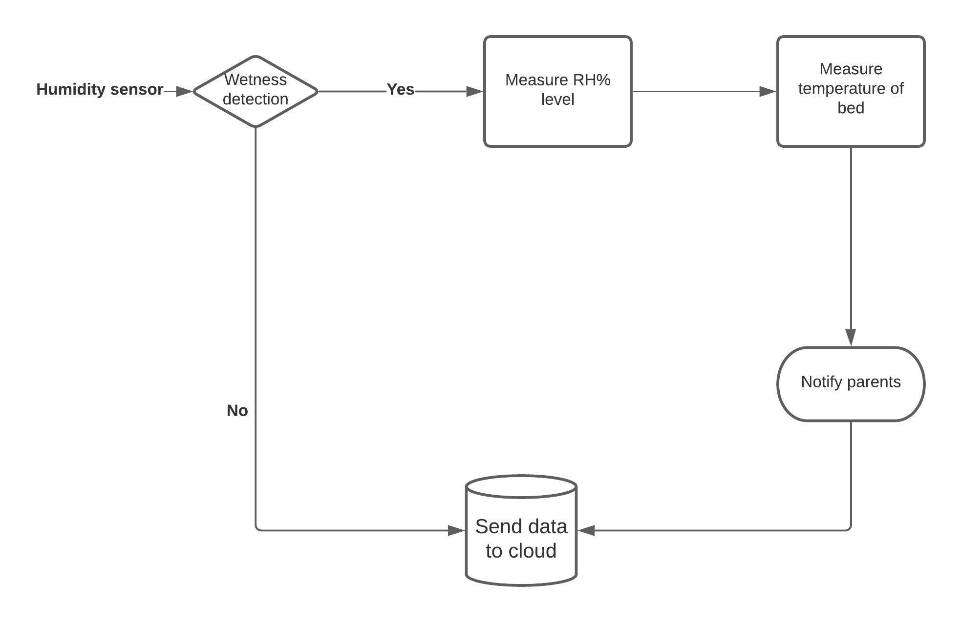

**5) video surveillance:**

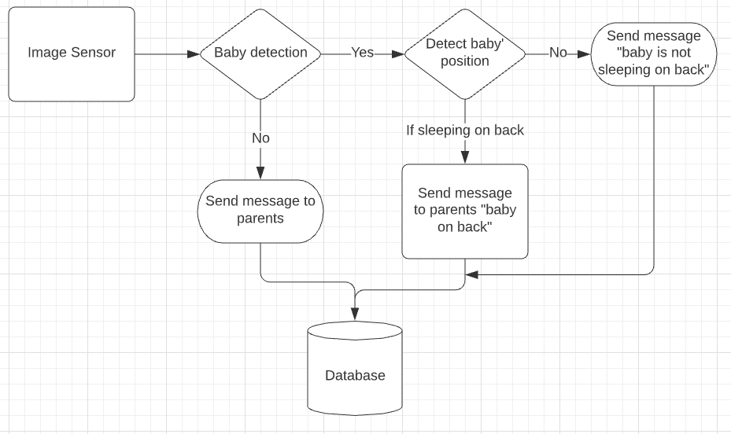

**Standard For Design:**

**Reading Data from DTH11 or DTH22**

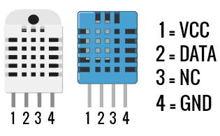

The DATA wire used for communication between microcontroller and DHT11/DHT22 is pulled HIGH using a 4.7K or 10K pull-up resistor. This is to bring the bus in an IDLE state when there is no communication taking place. A continuous HIGH on the line denotes an IDLE state. The microcontroller acts as the bus master and hence is responsible for initiating communication (i.e. Read). DHTxx Humidity and Temperature sensor always remains as slave and responds with data when MCU asks for it. The protocol used for communication is simple and can be summarized as follows:

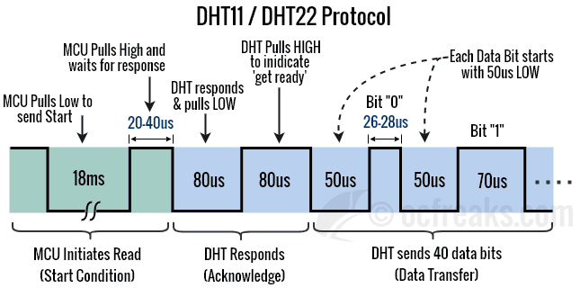

1. When the Line is IDLE the microcontroller pulls it to a LOW for 18ms.
2. After this MCU pulls it HIGH for around 20 to 40us.
3. DHTxx will detect it as a START from the MCU and respond by pulling the line LOW for 80us.
4. Next, DHTxx will pull it HIGH for 80us which indicates that it is ready to send data or “get ready”.
5. Next it will send 40 bits of Data. Each bit starts with a 50us LOW followed by 26-28us for a “0” or 70us for a “1”.
6. After communication ends, the Line is pulled HIGH by the pull-up resistor and enters IDLE state.

#### DHTxx Data Format

When a Humidity and Temperature sensor sends data, it sends the MSB first. The 40bits of data is divided into 5 bytes. For DHT11 sensors the 2nd and 4th byte is always Zero. The significance of these bytes is as follows:

* 1st Byte: Relative Humidity Integral Data in % (Integer Part)
* 2nd Byte: Relative Humidity Decimal Data in % (Fractional Part) – Zero for DHT11
* 3rd Byte: Temperature Integral in Degree Celsius (Integer Part)
* 4th Byte: Temperature in Decimal Data in % (Fractional Part) – Zero for DHT11
* 5th Byte: Checksum (Last 8 bits of {1st Byte + 2nd Byte + 3rd Byte+ 4th Byte})

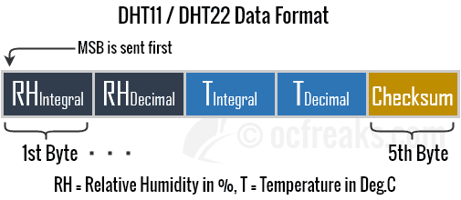

**Reading Data From MAX30100:**

MAX30100 Data can be read by I2C protocol.The MAX30100 features an I2C/SMBus-compatible, 2-wire serial interface consisting of a serial data line (SDA) and a serial clock line (SCL). SDA and SCL facilitate communication between the MAX30100 and the master at clock rates up to 400kHz

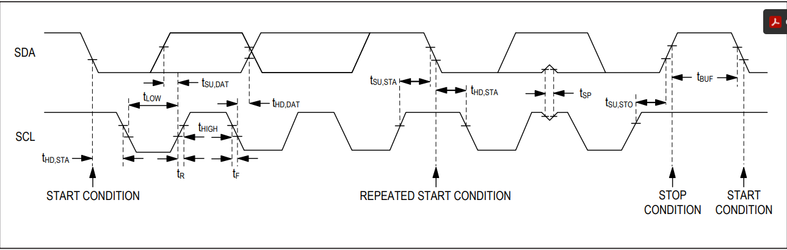

Figure shows the 2-wire interface timing diagram. The master generates SCL and initiates data transfer on the bus. The master device writes data to the MAX30100 by transmitting the proper slave address followed by data. Each transmit sequence is framed by a START (S) or REPEATED START (Sr) condition and a STOP (P) condition. Each word transmitted to the MAX30100 is 8 bits long and is followed by an acknowledged clock pulse. A master reading data from the MAX30100 transmits the proper slave address followed by a series of nine SCL pulses.The MAX30100 transmits data on SDA in sync with the master.

master-generated SCL pulses. The master acknowledges receipt of each byte of data. Each read sequence is framed by a START (S) or REPEATED START (Sr) condition, a not acknowledged, and a STOP (P) condition. SDA operates as both an input and an open-drain output. A pullup resistor, typically greater than 500Ω, is required on SDA. SCL operates only as an input. A pullup resistor, typically greater than 500Ω, is required on SCL if there are multiple masters on the bus, or if the single master has an open-drain SCL output.

**Controlling Motor:**

In our project, we are controlling a servo motor by L298N motor driver which has dual H-bridge configuration. This dual bidirectional motor driver is based on the very popular L298 Dual H-Bridge Motor Driver Integrated Circuit. The circuit will allow you to easily and independently control two motors of up to 2A each in both directions.It is ideal for robotic applications and well suited for connection to a microcontroller requiring just a couple of control lines per motor. It can also be interfaced with simple manual switches, TTL logic gates, relays, etc. This board equipped with power LED indicators, on-board +5V regulator and protection diodes.In general an H-bridge is a rather simple circuit, containing four switching element, with the load at the center, in an H-like configuration:

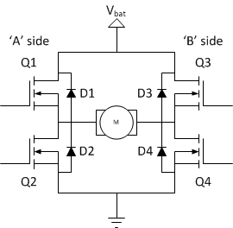

The switching elements (Q1..Q4) are usually bi-polar or FET transistors, in some high-voltage applications IGBTs. Integrated solutions also exist but whether the switching elements are integrated with their control circuits or not is not relevant for the most part for this discussion. The diodes (D1..D4) are called catch diodes and are usually of a Schottky type.The internal schematics of L298N is given below: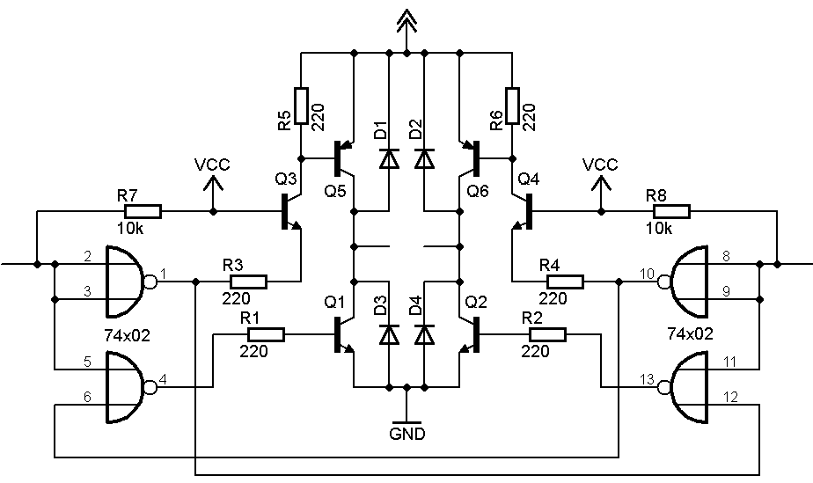

**Interacting Camera and Speaker with Raspberry pi:**

The Logitech C90 camera and Adafruit speaker have Usb cable and it uses a USB interface to interact with Raspberry pi. Here we will use driver fswebcam to interact with C90 in our host system which uses Usb protocol.

USB systems consist of a host, which is typically a personal computer (PC) and multiple peripheral devices connected through a tiered-star topology. This topology may also include hubs that allow additional connection points to the USB system. The host itself contains two components, the host controller and the root hub. The host controller is a hardware chipset with a software driver layer that is responsible for these tasks:

**Detect attachment and removal of USB devices**

**Manage data flow between host and devices**

**Provide and manage power to attached devices**

**Monitor activity on the bus**

At least one host controller is present in a host and it is possible to have more than one host controller. Each controller allows connection of up to 127 devices with the use of external USB hubs. The root hub is an internal hub that connects to the host controller(s) and acts as the first interface layer to the USB in a system. Currently on your PC, there are multiple USB ports. These ports are part of the root hub in your PC. For simplicity, look at the root hub and host controller from the abstract view of a ―black box‖ that we call the host.

USB devices consist of one or more device functions, such as a mouse, keyboard, or audio device for example. Each device is given an address by the host, which is used in the data communication between that device and the host. USB device communication is done through pipes. These pipes are a connection pathway from the host controller to an addressable buffer called an endpoint. An endpoint stores received data from the host and holds the data that is waiting to transmit to the host. A USB device can have multiple endpoints and each endpoint has a pipe associated with it. This is shown in Figure.

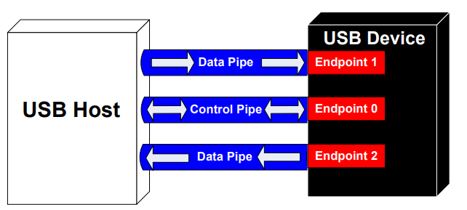

When a USB device is first connected to a host, the USB enumeration process is initiated. Enumeration is the process of exchanging information between the device and the host that includes learning about the device. Additionally, enumeration includes assigning an address to the device, reading descriptors (which are data structures that provide information about the device), and assigning and loading a device driver. This entire process can occur in seconds. When this process is complete, the device is ready to transfer data to the host. The flow chart of the general enumeration process is shown in Figure 2. Two files are affiliated with enumeration and the loading of a driver. They exist on the host side.

.INF – A text file that contains all the information necessary to install a device, such as driver names and locations, Windows registry information, and driver version information.

.SYS – The driver needed to communicate effectively with the USB device.

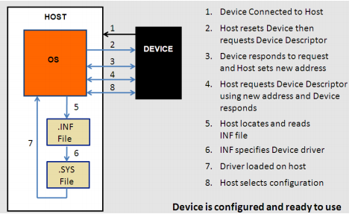

After a device is enumerated, the host directs all traffic flow to the devices on the bus. Because of this, no device can transfer data without a request from the host controller.

**Interacting PIR sensor:**

It has 3 pinouts. 1. VCC 2. Signal 3. GND. Its output is high when it detects infrared waves emitted by the body and gives output as a high to 2nd pi which will be interfaced to GPIO of raspberry pi.

**Microsoft Azure IoT Protocol:**

The Azure IoT protocol gateway is a framework for protocol adaptation that is designed for high-scale, bidirectional device communication with IoT Hub. The protocol gateway is a pass-through component that accepts device connections over a specific protocol. It bridges the traffic to IoT Hub over AMQP 1.0.

The Azure IoT protocol gateway includes an MQTT protocol adapter that enables you to customize the MQTT protocol behavior if necessary. Since IoT Hub provides built-in support for the MQTT v3.1.1 protocol, you should only consider using the MQTT protocol adapter if protocol customizations or specific requirements for additional functionality are required.

The MQTT adapter also demonstrates the programming model for building protocol adapters for other protocols. In addition, the Azure IoT protocol gateway programming model allows you to plug in custom components for specialized processing such as custom authentication, message transformations, compression/decompression, or encryption/decryption of traffic between the devices and IoT Hub.

For flexibility, the Azure IoT protocol gateway and MQTT implementation are provided in an open-source software project. You can use the open-source project to add support for various protocols and protocol versions, or customize the implementation for your scenario.

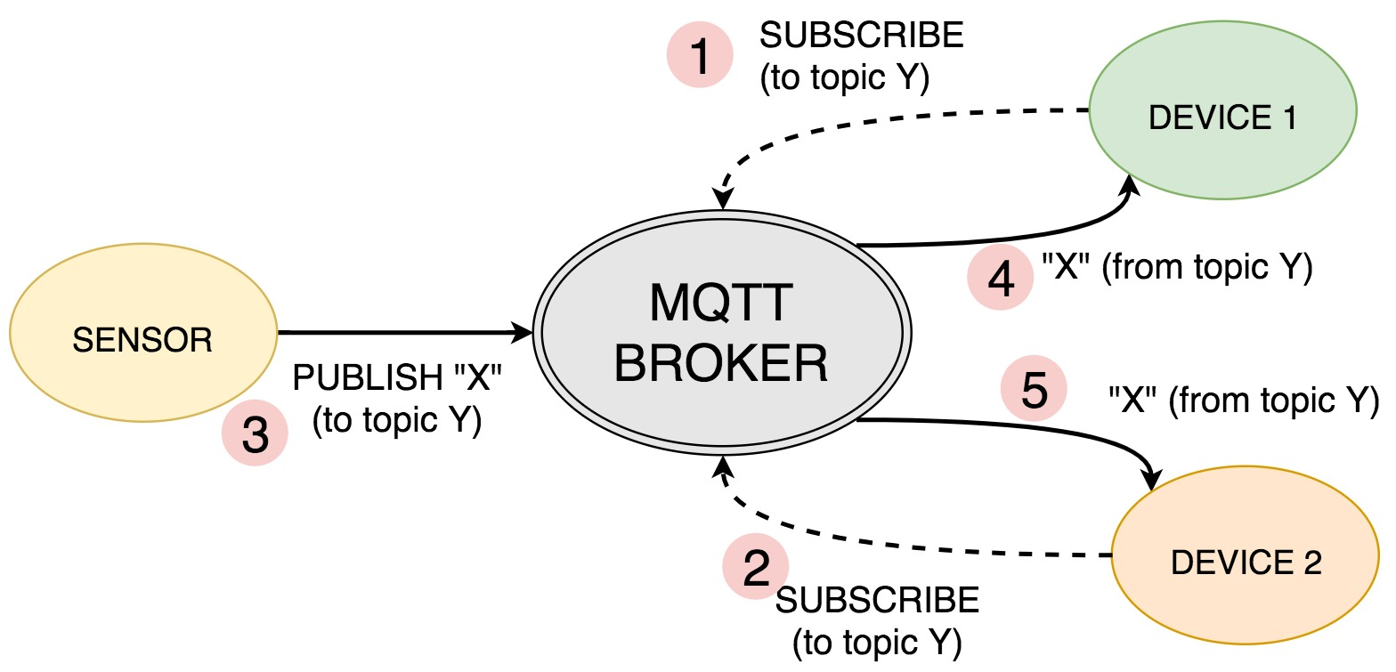

**GSM interface with Raspberry pi:**

SIM 868 module is being used in this device which is a complete Quad-Band GSM/GPRS module which combines GNSS technology for satellite navigation. In the left side of the module you can see a yellow jumper connected to the suitable pins. There are four pairs of pins in which the jumpers must be shorted to make three terminal pairs (A,B,C).

A: control the SIM868 through USB TO UART

B: control the SIM868 through Raspberry Pi

C: access Raspberry Pi through USB TO UART

Here we make use of A terminal, i.e. the jumpers must be connected vertically in the first two pins as shown in the figure given below.

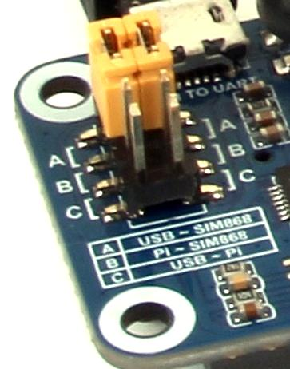

**Coding:**

We will use c programming with implementation of threads to achieve Multitasking features in our project. In addition to that, we will use Procedure based c programming on top of Running linux OS to achieve Real-time processing attributes.

It is possible to turn Linux into a real-time operating system by applying the PREEMPT_RT patch set.PREEMPT_RT patched Linux is a great match for the industrial machines that we are helping to build at that time.

**Project Milestone:**

|  |  |  |  |  |
| --- | --- | --- | --- | --- |
| **Sr. No.** | **Task** | **Start date** | **End date** | **Name** |
| **1.** | **Project proposal** | **MAY 10,2021** | **JUN 03,2021** | **All group** |
| **2.** | **Testing components** | **JUN O7,2021** | **JUN 10,2021** | **Shahrukh** |
| **3.** | **Setting up Raspberry pi** | **JUN 11,2021** | **JUN 14,2021** | **Swapnil** |
| **4.** | **Video Recorder interfacing** | **JUN 15,2021** | **JUN 21,2021** | **Vandana** |
| **5.** | **Pulse oximeter interfacing** | **JUN 22,2021** | **JUN 24,2021** | **Rohan** |
| **6.** | **Humidity sensor interfacing** | **JUN 25,2021** | **JUN 28,2021** | **Vandana** |
| **7.** | **PIR sensor interfacing** | **JUN 29,2021** | **JUN 30,2021** | **Swapnil** |
| **8.** | **GSM module interfacing** | **JUN 01,2021** | **JUN 05,2021** | **Shahrukh** |
| **9.** | **Motor interfacing(Motor driver + electrical motor)** | **JUN 06,2021** | **JUL 08,2021** | **Rohan** |
| **10.** | **Speaker interfacing(Speaker driver + speaker)** | **JUL 09,2021** | **JUL 12,2021** | **Vandana** |
| **11.** | **Cloud store management** | **JUL 13,2021** | **JUL 19,2021** | **Rohan** |
| **12.** | **Schematic Capture design** | **JUL 20,2021** | **JUL 22,2021** | **Shahrukh** |
| **13.** | **PCB layout design** | **JUL 23,2021** | **JUL 26,2021** | **Swapnil** |
| **14.** | **PCB component implementation** | **JUL 27,2021** | **JUL 29,2021** | **Rohan** |
| **15.** | **Code integration** | **JUL 30,2021** | **AUG 05,2021** | **Shahrukh** |
| **16.** | **Real-time operation** | **AUG 06,2021** | **AUG 09,2021** | **Swapnil** |
| **17.** | **Power management** | **AUG 10,2021** | **AUG 12,2021** | **Vandana** |
| **18.** | **Final report Presentation** | **AUG 12,2021** | **AUG 16,2021** | **Group** |
| **19.** | **Final project Presentation** | **AUG 18,2021** | **AUG 19,2021** | **Group** |

**Environmental, legal and ethical ramifications:**

**Materials**: Getting the raw materials out of the ground is just the first step; to be useful, they must be processed and refined. Rare earth materials typically require repeated treatments with strong acids in order to separate them from unwanted substances, which creates a huge waste disposal problem. To Overcome this problem, we will make sure that all materials we use, should be recyclable, hence, it will not harm the environment additionally. Also the materials used for our project would be selected to provide the highest safety and security to the baby.

**Shipping**: It takes energy to move an object from here to there. Much of electronic equipment is transported by ocean freighters in shipping containers, which is one of the most efficient means available, but it adds up. (About 90 percent of global trade travels at least part of its journey on ships.) While efficient, ships use low-grade fuel oil that contains sulfur and can be highly polluting. To overcome this challenge, we will try to purchase our components locally or in bulk at once, so harm due to shipping can be avoided.

**Power**: Generating that power comes with its own environmental impact, whether by using fossil fuels, nuclear energy, or “renewable” sources such as wind or solar. So we will try to minimize power consumption. We also decided to choose more efficient components in our project. We have decided to use the power from the socket, instead of using a battery, as it affects the environment adversely.

**Disposal**: We will maintain contact with our consumers and collect all our components with reasonable prices so that we can reuse the same components after some testing and modification if any components are not in working condition. This will reduce E-waste which will help in reducing the effect of global warming.

**Allergic reaction and safety:** Our product is an electric product and some parts like pulse oximeters would be directly connected to the body of the baby. Although we are working with low power electronics, there is some electromagnetic radiation. Some babies may be allergic to this. So to avoid any lawsuit, we will add a caution sign in the manual and also notify the parents about this. Further, we will give a trial period for a couple of weeks, so that the customer can return the product if there is any allergic reaction. Also we will take care of the safety of the product and all the wiring will be insulated properly.

**BOM:**

|  |  |  |  |  |  |
| --- | --- | --- | --- | --- | --- |
| Sr. No. | Components | Quantity | Part Number | Price | Reference |
| 1. | RASPBERRY PI 3 | 1 | RASPBERRY PI 3 | $47.79 | <https://www.digikey.ca/en/products/detail/diodes-incorporated/ZXLD383ET5TA/2059443> |
| 2. | Motor Driver | 1 | L298N | $7.87 | <https://www.digikey.ca/en/products/detail/stmicroelectronics/L298N/585918> |
| 3. | Pulse Oximeter | 1 | MAX30102 | $12.77 | <https://www.digikey.ca/en/products/detail/maxim-integrated/MAX30102EFD-T/6188734> |
| 4. | Resistor | 2 | CFR-25JB-52-1K | $0.15 | <https://www.digikey.ca/en/products/detail/yageo/CFR-25JB-52-1K/96> |
| 5. | Mini External USB Stereo Speaker | 1 | 3369 | $12.50 | <https://www.adafruit.com/product/3369> |
| 6. | GSM/GPRS module | 1 | SIM868 | $20.30 | <https://www.amazon.ca/SIM868-Cellular-Module-Breakout-Instead/dp/B07VYWVLL9> |
| 7. | PIR sensor | 1 | 1528-1991-ND | 13.80 | <https://www.digikey.ca/en/products/detail/adafruit-industries-llc/189/6827035> |
| 8. | Logitech C920  Camera | 1 | C920 | $99.99 | <https://www.logitech.com/en-ca/products/webcams/c920-pro-hd-webcam.960-000764.html> |
| 9. | Humidity sensor DTH11 | 1 | 386 | $7.27 | <https://www.digikey.ca/catalog/en/partgroup/dht11-basic-temperature-humidity-sensor-plus-extras/59800> |
| 10. | Servo Motor | 1 | 1528-1501-ND | $10.40 | <https://www.digikey.ca/en/products/detail/adafruit-industries-llc/2442/5774227> |
| 11. | Motor Driver | 1 | 1528-1795-ND | $6.45 | <https://www.digikey.ca/en/products/detail/adafruit-industries-llc/3297/6419360> |
| 11 | Baby Cradle | 1 |  | $69.97 | <https://www.walmart.ca/en/ip/bily-rocking-bassinet-arctic-bear/6000196213149> |
| 12. | PCB design | 1 |  | $100 | Approximately |
| 13. | Sparkfun beginning toolkit | 1. | TOL-14681 | $57.95 | <https://www.sparkfun.com/products/14681> |

**Instructor’s Remarks:-**

**References :**

1.R. S. C. Horne, ‘‘Sudden infant death syndrome: Current perspectives,’’ Int. Med. J., vol. 49, no. 4, pp. 433–438, 2019.

2. B. J. Taylor, J. Garstang, A. Engelberts, T. Obonai, A. Cote, J. Freemantle, M. Vennemann, M. Healey, P. Sidebotham, E. A. Mitchell, and R. Y. Moon, ‘‘International comparison of sudden unexpected death in infancy rates using a newly proposed set of cause-of-death codes,’’Arch. Disease Childhood, vol. 100, no. 11, pp. 1018–1023, 2015.

3.A. B. E. Lambert, S. E. Parks, and C. K. Shapiro-Mendoza, ‘‘National and state trends in sudden unexpected infant death: 1990–2015,’’ Pediatrics, vol. 141, no. 3, 2018, Art. no. e20173519.

4.I. Jhun, D. A. Mata, F. Nordio, M. Lee, J. Schwartz, and A. Zanobetti, ‘‘Ambient temperature and sudden infant death syndrome in the United States,’’ Epidemiology, vol. 28, no. 5, pp. 728–734, 2017.

5. Jubran A. Pulse oximetry. *Crit Care.* 1999;**3**:R11–7. doi: 10.1186/cc341.

6. Wukitsch MW, Petterson MT, Tobler DR, Pologe JA. Pulse oximetry: analysis of theory, technology, and practice. *J Clin Monit.* 1988;**4**:290–301. doi: 10.1007/BF01617328.

7. Wouters PF, Gehring H, Meyfroidt G, Ponz L, Gil-Rodriguez J, Hornberger C, et al. Accuracy of pulse oximeters: the European multi-center trial. *Anesth Analg.* 2002;**94**(1 Suppl):S13–6.

8. Santiago Lopez,Pulse Oximeter Fundamentals and Design,Rev. 2, 11/2012,Document Number:AN4327

9.*Design and Fabrication of Automatic Baby CradleSystem*. (n.d.). Learn mech.com.

https://learnmech.com/

10. *C920 HD Pro Webcam*. (n.d.). logitech. https://www.logitech.com/en-ca/products/webcams/c920-pro-hd-webcam.960-000764.html?version

11. Gerald Coley, BeagleBone Black System Reference Manual, Rev A5.2, April 2013

12.Rebecca Edwards(Security Expert, Safety & Tech Reporter), Owlet Smart Sock Review, March 27,2020

*13.Nanit Pro Camera: Nanit Canada*. Nanit Pro Camera | Nanit Canada. (n.d.). [https://www.nanit.com/ca/products/nanit-pro-camera](https://www.nanit.com/ca/products/nanit-pro-camera?mount=wall-mount&utm_source=google&utm_medium=cpc&utm_campaign=Shopping_Canada&gclid=CjwKCAjwhYOFBhBkEiwASF3KGZJ-b6jBx0Ghj4hY-UDM6P3FTeZnOGHBAC0F-E-fhKnxIiN73OhewBoCO7UQAvD_BwE)

*14.Owlet Smart Sock Baby Monitor (3rd Gen): Walmart Canada*. Walmart.ca. (n.d.). [https://www.walmart.ca/en/ip/owlet-smart-sock-baby-monitor-3rd-gen/6000201862698](https://www.walmart.ca/en/ip/owlet-smart-sock-baby-monitor-3rd-gen/6000201862698?utm_medium=paid_search&utm_source=google&utm_campaign=always_on&cmpid=SEM_CA_73_JGXSHQ12S0_71700000053537233_58700005327969290&utm_id=SEM_CA_73_JGXSHQ12S0_71700000053537233_58700005327969290&gclsrc=aw.ds&&gclid=CjwKCAjwhYOFBhBkEiwASF3KGR1ZmP-IItJPx92gyIgkAnFCCCvGWzr9oslFJQuBTTvLAKniFxzATRoC-pcQAvD_BwE)

15. *Difference Between Servo Motor and DC Motor*. (n.d.). Circuit globe. <https://circuitglobe.com/difference-between-servo-motor-and-dc-motor.html>

16.*Microprocessor - RASPBERRY PI 3 MOD B+ BCM2837B0*. (n.d.). <https://static.raspberrypi.org/files/product-briefs/Raspberry-Pi-Model-Bplus-Product-Brief.pdf>

17.Dogan, I. (2020). Multitasking with raspberry pi. <https://www.elektormagazine.com/articles/multitasking-with-raspberry-pi>

18.C vs Python. (2020, april). <https://www.geeksforgeeks.org/c-vs-python/>

19. *Simplify IoT development and drive digital transformation with your Azure free account*. (n.d.). Microsoft Azure. <https://azure.microsoft.com/en-us/free/iot/#12-months-free>

20.*DHT11 vs DHT22 vs LM35 vs DS18B20 vs BME280 vs BMP180*. (n.d.). Random Nerd Tutorials. <https://randomnerdtutorials.com/dht11-vs-dht22-vs-lm35-vs-ds18b20-vs-bme280-vs-bmp180/>

21.*Interface PIR Motion Sensor with Raspberry Pi*. (n.d.). MB Tech Works. <https://www.mbtechworks.com/projects/pir-motion-sensor-with-raspberry-pi.html>

22.*GSM/GPRS/GNSS/Bluetooth HAT for Raspberry Pi*. (n.d.). Waveshare. <https://www.waveshare.com/gsm-gprs-gnss-hat.htm>

23.*Basics of Interfacing DHT11/DHT22 Humidity and Temperature Sensor with MCU*. (n.d.). OCFREAKS. <http://www.ocfreaks.com/basics-interfacing-dht11-dht22-humidity-temperature-sensor-mcu/>

24. *Datasheet of MAX30100*. (n.d.). <https://datasheets.maximintegrated.com/en/ds/MAX30100.pdf>

25. *Controlling Motor*. (n.d.). Modular Circuits. <https://www.modularcircuits.com/blog/articles/h-bridge-secrets/h-bridges-the-basics/>

26. Murphy, R. (n.d.). An Introduction to Universal Serial Bus 2.0. *CYPRESS*. <https://www.cypress.com/file/134171/download#:~:text=USB%20devices%20consist%20of%20one,communication%20is%20done%20through%20pipes>

27.*Microsoft Azure IoT Protocol*. (n.d.). Microsoft. <https://docs.microsoft.com/en-us/azure/iot-hub/iot-hub-protocol-gateway>

28. *Real-Time Linux on the Raspberry Pi*. (n.d.). edi. <https://www.get-edi.io/Real-Time-Linux-on-the-Raspberry-Pi/>

29.*Interfacing Gsm/Gprs/Gnss/Bluetooth Hat With Raspberry Pi 3*. (n.d.). Rhydol. <https://www.rhydolabz.com/wiki/?p=18639>